August 2nd, 2022
Dear ICH members,
We are so grateful to the ICH for collecting books to benefit our program. The 175 books you collected will ensure that even more at-risk students in Houston have access to age-appropriate books in their homes. Thank you!
For the past nine years, Books Between Kids has been working to improve access to books for children in low-income communities. With the disruptions to school and daily life due to Covid-19, our mission is more important than ever. This year we will be distributing over 300,000 books to at-risk students at 52 School Book Celebrations, as well as through our Community Partners Program. We are working hard to expand our ability to reach at-risk students, and we couldn’t do it without your support!
If you have not already done so, we invite you to follow our work on Facebook @BooksBetweenKids, Instagram at booksbetweenkids, or Twitter at @BooksBtnKids. Thank you for reaching out and supporting our efforts to continue getting books into the hands of children in Houston who need them the most.
Sincerely,
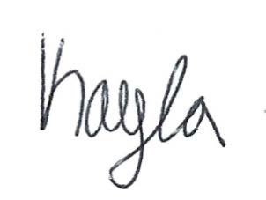
Kayla Hand
Executive Director
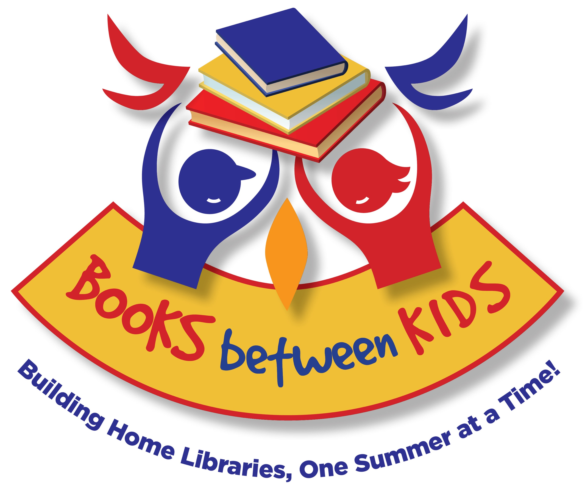The Books Between Kids Team
www.booksbetweenkids.org
email: info@booksbetweenkids.org
phone: (832) 831-1402

