May 26th, 2022
Dear ICH members,
We are so grateful to you and the ICH for hosting a book drive to benefit our program. The 257 books you collected will ensure that even more at-risk students in Houston have access to age-appropriate books in their homes. Thank you!
For the past nine years, Books Between Kids has been working to improve access to books for children in low-income communities. With the disruptions to school and daily life due to Covid-19, our mission is more important than ever. This year we will be distributing over 300,000 books to at-risk students at 52 School Book Celebrations, as well as through our Community Partners Program. We are working hard to expand our ability to reach at-risk students, and we couldn’t do it without your support!
Thank you for reaching out and supporting our efforts to continue getting books into the hands of children in Houston who need them the most.
Sincerely,
Kayla Hand
Executive Director
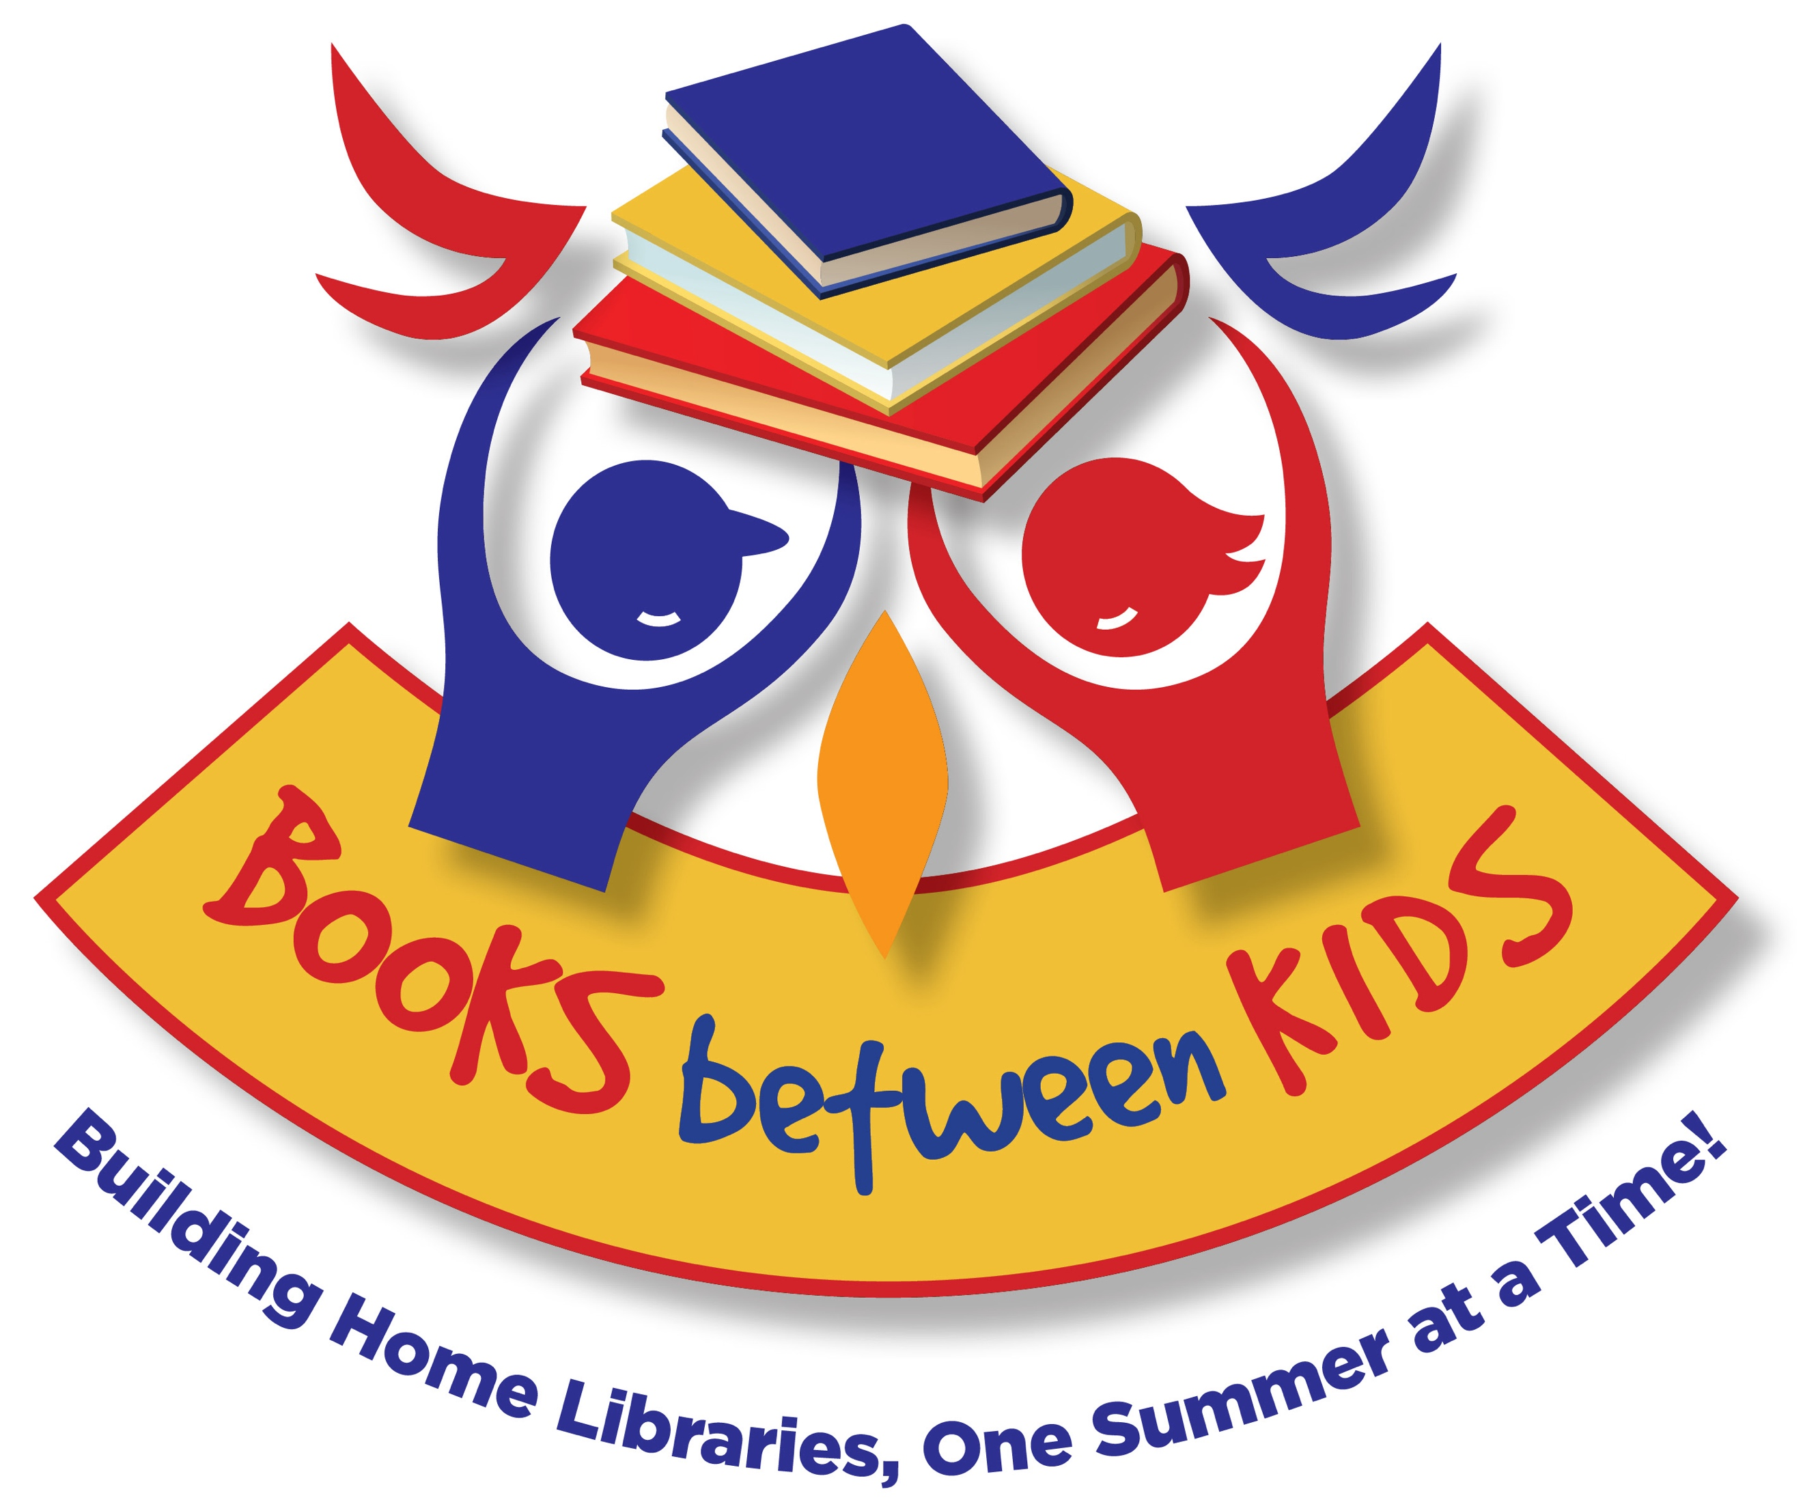
The Books Between Kids Team
www.booksbetweenkids.org

