Nov 22, 2022

Dear International Connections of Houston.

Your Donation of $1,000 has already been providing much needed support. Here's the unedited update from the field:
An update on your donation to the Ukraine Crisis Relief Fund
By Sarah Rahman - Disaster Response Program Manager
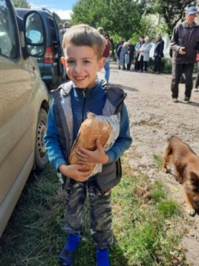
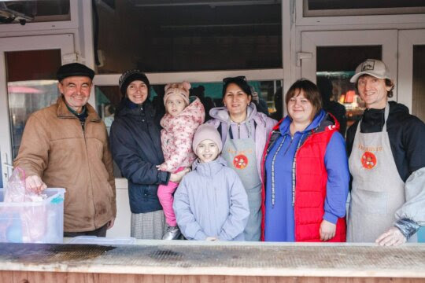

Photo: Nova Ukraine/Angels of Salvation

Photo: Food for Life Ukraine
Thank you for your generous donation to the Ukraine Crisis Relief Fund. Donations to this GlobalGiving fund have been making a difference since the latest Russian invasion of Ukraine earlier this year, helping nonprofit organizations save lives and strengthen their resilience.
"GlobalGiving’s [grant] comes in just as my team has been trying to figure out how to keep our efforts going and accelerate through the long winter. We know how critical support will be in the coming months when many are pulling back because public donations and interest have waned." – Randi, Kidsave International
Here is a short description of some of the critical work you’ve supported:
Food for Life Ukraine provides hot meals for communities across Ukraine, with special attention to dietary and cultural preferences. This is critically important as the recent increase in military strikes leaves millions of Ukrainians without electricity to cook.
Global Fund for Children is dedicated to supporting grassroots organizations that empower children and youth, including in Ukraine and Poland. The organization is supporting humanitarian needs during winter and activities focused on educational and psychosocial support for children affected by conflict.
Your support for the Ukraine Crisis Relief Fund powers community-led responses, and it means war-torn parts of Ukraine and refugees in the region get the critical resources they need to help their community recover and rebuild. Thank you for your support for the future of Ukrainians.
With gratitude,
Sarah + the GlobalGiving team

